

COLLEGE of INFORMATICS and ELECTRONICS

Department of Computer Science
and Information Systems

End-of-Semester Assessment Paper

Academic Year: | 2004/05 | Semester: | Semester 5
Module Title: | Computer Networks | Module Code: | CS4225
Duration of Exam: | 2½ Hours | Percent of Total Marks: | 78
Lecturer(s): | Dr Séamus O’Shea | Paper marked out of : | 100

Instructions to Candidates:

- Answer any three questions.

1.
- Briefly explain what ‘source encoding/decoding’ and ‘channel encoding/decoding’ mean, giving examples. (11 marks)
- Draw a diagram to show two periodic signals which are (i) 90º (ii)45º and (iii) 180º out of phase with respect to each other. (Assume same frequency and amplitude) (10 marks)
- The following diagram shows a modulated analog signal. Describe the type of modulation in use in this example. How many distinct phase changes occur? How many separate line states can be distinguished? (12 marks)

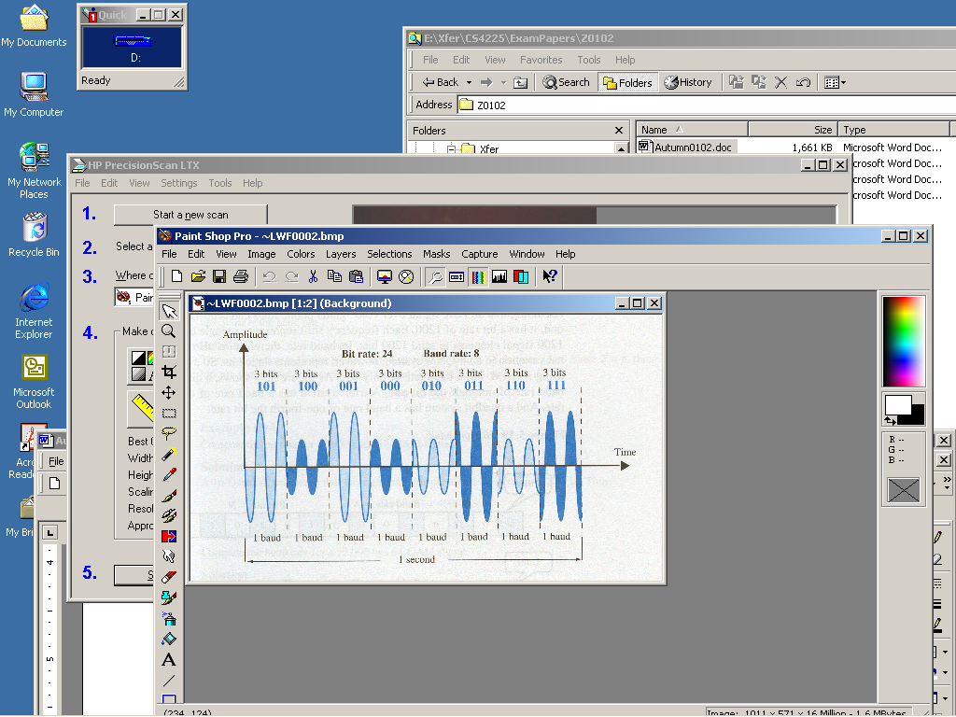

2.
- Define the decibel unit of signal intensity. If signal S₁ is 20 db greater than signal S₂, what is the ratio (S₁/S₂) in absolute terms? (10 marks)
- How can the bit rate of a channel be estimated given the bandwidth and noise levels? (10 marks)
- Suppose a digital video camera (i.e camcorder) generates 25 colour images per second, whose resolution is 1024 x 768 pixels. A pixel’s colour is encoded using 8 bits. The images are transmitted over a link whose bandwidth is 4.5Mhz and whose signal-to-noise ratio is 35dB.In the absence of any compression, will the link be able to carry the transmission? (13 marks)

3.
- Show, via examples, how classfull IP address allocation is wasteful, and how CIDR reduces such waste. (8 marks)
- A network interface on a user’s PC is allocated the IP address 192.168.6.19 with a corresponding mask of 255.255.255.192. How many bits does the ‘hostid’ part of the address contain? (6 marks)
- The user’s PC has a Default Gateway configuration of 192.168.6.65, and an associated mask of 255.255.255.192. The PC user pings the interface 192.168.8.11. Explain the results. (9 marks)
- Which of the address blocks,132.45.96.0/19 and 132.45.96.0/22, is the smaller? How many of the smaller blocks are contained in the larger block? (11 marks)

4.
- Draw a diagram to show the necessary exchange of messages to set up a TCP client connection to a server. (4 marks)
- Give examples of connection attributes that can be negotiated at set up time. (5 marks)
- On transmission, is the IP datagram encapsulated in the TCP segment, or is the TCP segment encapsulated in the IP datagram? (4 marks)
- What is the TCP response if a received segment fails the checksum? How does TCP recognise received segments which are not in sequence? (5 marks)
- How does TCP differentiate between client connections which are multiplexed onto the same server port? (5 marks)
- Describe how retransmission of messages in a TCP connection is triggered . (5 marks)
- How is flow control achieved between two communicating TCP entities? (5 marks)

5.
- Give examples of how the need for ‘address resolution’ arises in the context of the TCP/IP protocol stack. (8 marks)
- Describe how the ARP protocol resolves IP addresses. Suppose you ‘ping’ a node on a remote network. Explain the entry that is found in the ARP cache corresponding to the ping. (9 marks)
- In the context of address resolution, describe how a URL such as ‘www.website.com’ is reached from your PC. (Assume a TCP/IP stack). What are the implications for the PC configuration? (9 marks)
- Give examples to show how ‘caching’ can be useful in the process of address resolution. (7 marks)

